Purchase Agreement 2022-26

Mid-year Performance Report December 2025
police.act.gov.au

Contents
1. Summary 3
2. Performance Measures Overview 4
3. Performance Measures and Indicators of Effectiveness Results 8
4. Ministerial Direction and Statement of Intent 20

Report details
Originating area | ACT Policing Statistics
Date Published
Cleared by | Chief Police Officer

1. Summary
The ACT Policing 2025-26 Mid-Year Performance Report (period 1 July 2025 to 31 December 2025)¹ outlines the performance of ACT Policing against the Purchase Agreement for the Provision of Policing Services 2022-26 and the Ministerial Direction issued by the ACT Minister for Police, Fire and Emergency Services in 2025.

2022-26 Performance Measure Framework
Schedule 1 of the Purchase Agreement outlines 21 performance measures under two outcomes:

Shared ACT Government Outcomes

Outputs: Victimisation rate
Repeat offender rate
Road crashes resulting in death or injury

ACT Policing Operational Outcomes

Outputs: Divert
Disrupt
Respond
Enforce
Community Confidence

Key Performance Indicators
When analysing the data, it is important to note the impact of COVID-19 on 2019-20 to 2021-22 crime statistics. Notably, lockdowns and other related restrictions have resulted in significant variations to crime trends. Comparisons made with any previous years and/or trends need to be considered with this in mind.

2. Performance Measures Overview
Shared ACT Government Outcomes
*Pro-rata financial year results where relevant

ACT Policing Operational Outcomes
*Pro-rata financial year results where relevant

5 Year Trends
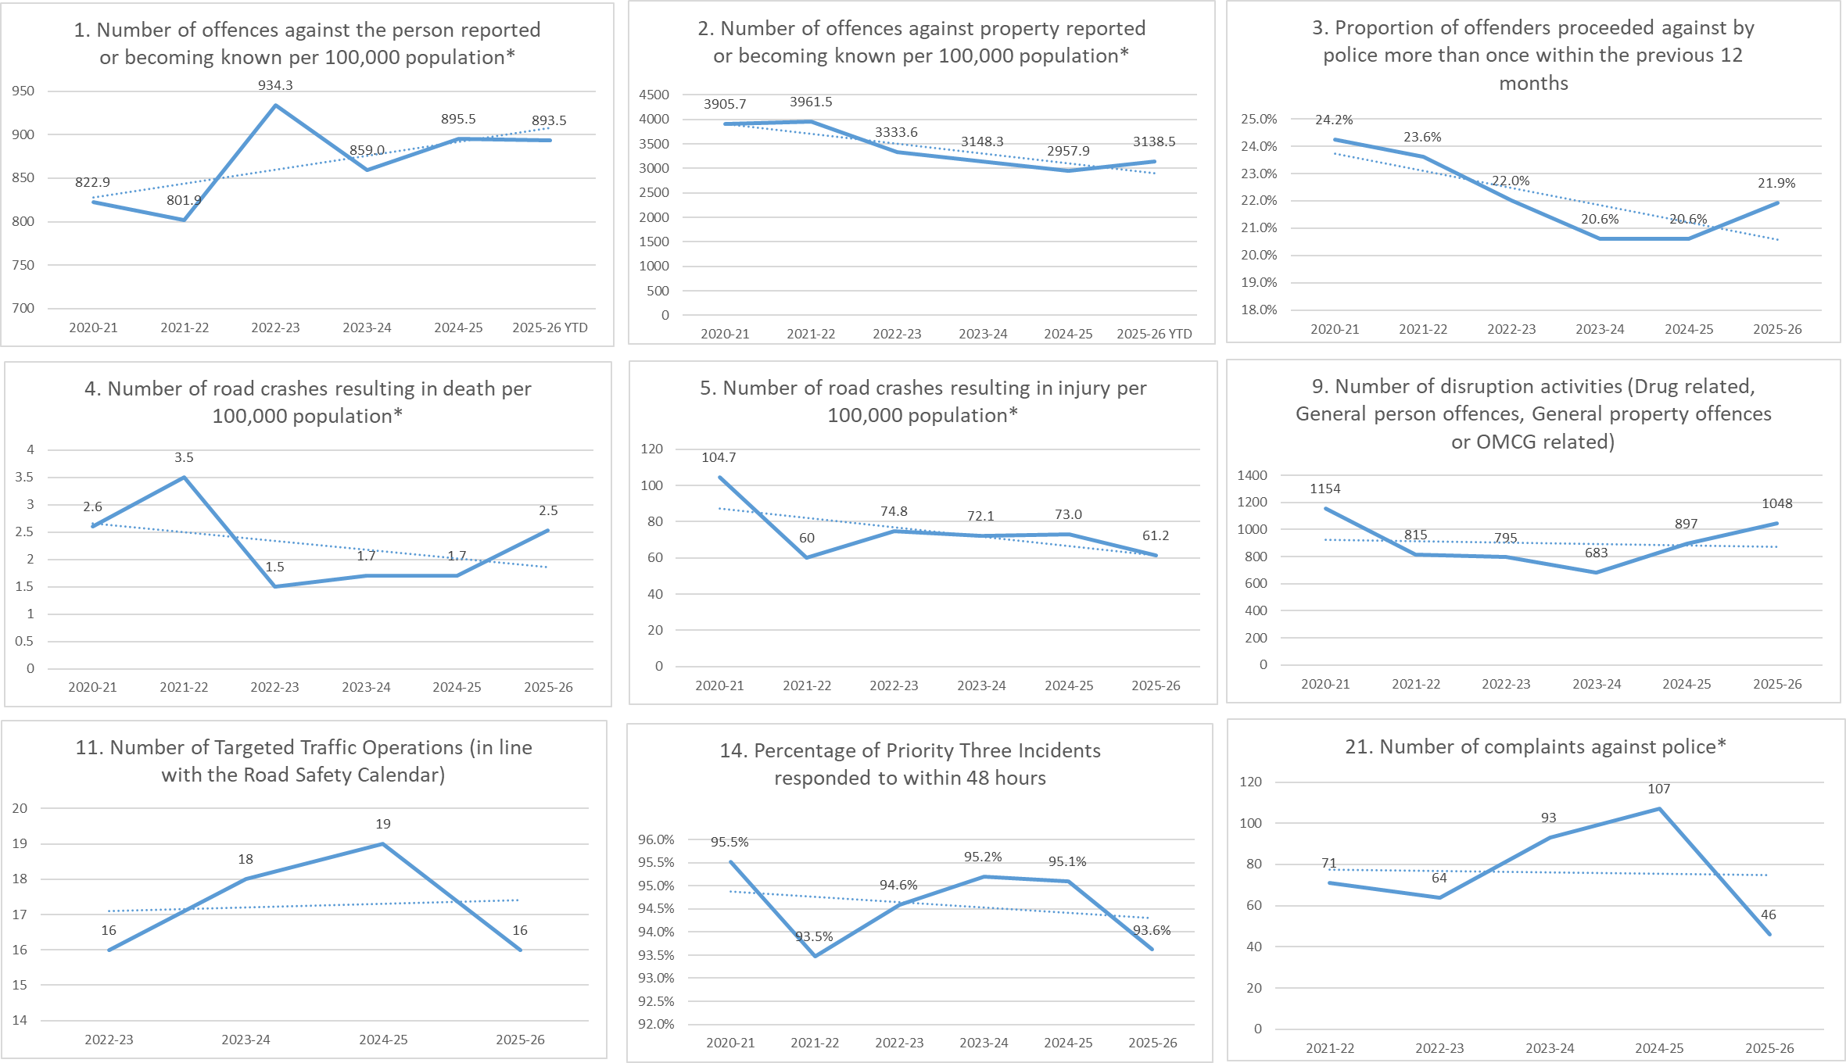

3. Performance Measures and Indicators of Effectiveness Results
Shared ACT Government Outcomes

OUTCOME: Prevent Crime
Performance Measure 1 - Number of offences against the person reported or becoming known per 100,000 population
Time Period | Target | Result
1 Jul 2025 – 31 Dec 2025 | Monitor 5-year trend | 893.5*
Figure 1: Offences against the person reported or becoming known per 100,000 population – 5-year trend
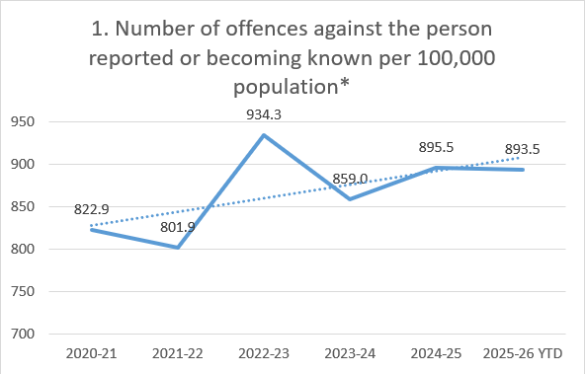
*Figures for the 2025-26 FY have been provided on a pro-rata basis.
The pro-rata estimate of person offences reported or becoming known per 100,000 population for the 2025-26 Financial Year is 893.5. Whilst this is above average in comparison to the past 5 years it’s important to note that 2 of the 5 previous years within the period monitored were impacted by COVID restrictions, which had a significant impact on person offences.
Performance Measure 2 - Number of offences against property reported or becoming known per 100,000 population
Time Period | Target | Result
1 Jul 2025 – 31 Dec 2025 | Monitor 5-year trend | 3138.5*
Figure 2: Offences against property reported or becoming known per 100,000 population – 5-year trend
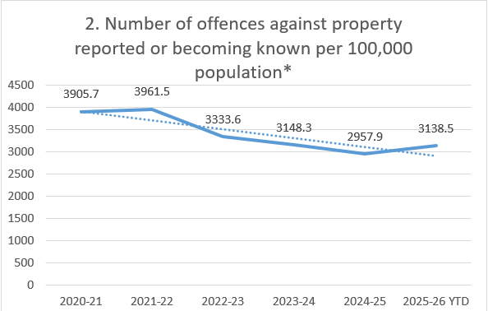
*Figures for the 2025-26 FY have been provided on a pro-rata basis.
For period 01 July 2025 to 31 December 2025, the pro-rata figure of property offences reported or becoming known per 100,000 population for 2025-26 is 3138.5. This result is the first time since 2021-22 that property offences have increased year-on-year; however the result is still significantly lower than the results seen at the beginning of the 5-year period.
Figure 2 shows a continual long term downward trend for reported property offences per 100,000 population.
Performance Measure 3 – Proportion of offenders proceeded against by police more than once within the previous 12 months
Date Range | Target | Result
1 Jan 2025 – 31 Dec 2025* | Monitor 5-year trend | 21.9%**

Figure 3: Proportion of offenders proceeded against by police more than once within the previous 12 months – 5-year trend
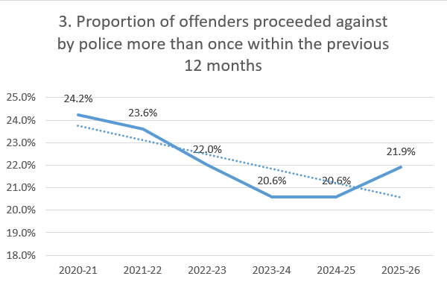
The proportion of offenders proceeded against by police more than once within the previous 12 months is 21.9%**. This is a slight increase in comparison with the previous 2 results; however is still below the levels recorded earlier in the 5-year period.
**In order to provide a genuine comparison, the result data must consider a 12-month period. As such, the date range used for this data is January 1st 2025 – December 31st 2025.

OUTCOME: Prevent Road Deaths and Trauma
Performance Measure 4 – Number of road crashes resulting in death per 100,000
Date Range | Target | Result
1 Jul 2025 – 31 Dec 2025 | Monitor 5-year trend | 2.5 / 100,000 people*
Figure 4: Number of road crashes resulting in death – 5-year trend
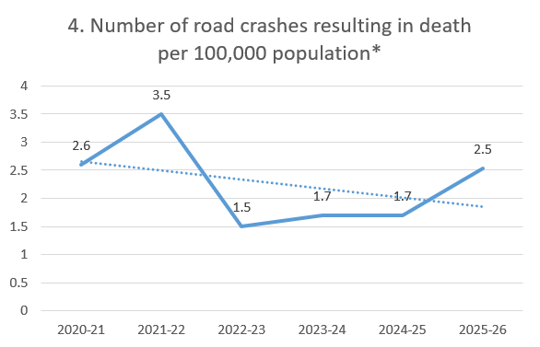
*Figures for the 2025-26 FY have been provided on a pro-rata basis.

The projected rate of road crashes resulting in death per 100,000 for the 2025-26 FY is 2.5 crashes per 100,000 people. Whilst this result is an increase on the previous three results, it is a decrease on the 2021/22 and 2020/21 FYs.
Performance Measure 5 - Number of road crashes resulting in injury per 100,000
Date Range | Target | Result
1 Jul 2025 – 31 Dec 2025 | Monitor 5-year trend | 61.2 injuries / 100,000 people*
Figure 5: Number of road crashes resulting in injury – 5-year trend
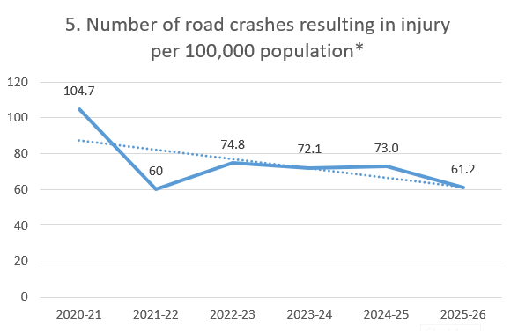
*Figures for the 2025-26 FY have been provided on a pro-rata basis.
The pro-rata estimate of road crashes resulting in injury per 100,000 for the 2025-26 period is 61.2 per 100,000 people.
This result follows the downward trend of the past 5 years, and is the lowest result seen in the ACT since the 2021-22 FY.

ACT POLICING OPERATIONAL OUTCOMES

OUTCOME: Divert
Performance Measure 6 - Percentage of eligible young people referred to Restorative Justice (RJ)
6.1 Aboriginal and Torres Strait Islander
Date range | Target | Result | % Variation from target | On target
1 Jul 2025 – 31 Dec 2025 | 100% | 66.7% | -33.3% | N

6.2 Non-Indigenous
Date range | Target | Result | % Variation from target | On target
1 Jul 2025 – 31 Dec 2025 | 100% | 59.0% | -41.0% | N

During the period, four First Nations young persons of the six eligible for RJ have been referred by ACT Policing. 23 out of 39 non-indigenous young people eligible for RJ have been referred.
ACT Policing’s policy is to refer all eligible offenders including all eligible First Nations to RJ and to work with Government and non-government partners to identify options for increased diversion and community-based referrals. ACT Policing strictly applies the RJ eligible criteria and endeavours to refers all eligible person each case is reviewed separately and whilst a number of individuals were deemed eligible due to the specific nature of some cases the case officer chose not to refer the individual in certain circumstances.
At the time of writing there were also a number of outstanding cases where the alleged offenders eligibility has yet to be determined prior to court appearance(s).
Performance Measure 7 - Percentage of offenders proceeded against by non-court actions (diversions and cautions)
7.1 Aboriginal and Torres Strait Islander
Date range | Target measure | Actual target | Result | % Variation from target | On target
1 Jul 2025 – 31 Dec 2025 | 5 Year average or more | 5.9% | 6.3% | 0.4% | Y

The percentage of First Nation offenders proceeded against by non-court actions (diversionary conferences, alcohol and drug diversions and cautions) is 6.3%. This is 0.4% above the target of 5.9% (average over the past five years).
7.2 Non-Indigenous
Date Range | Target measure | Actual target | Result | % Variation from target | On target
1 Jul 2025 – 31 Dec 2025 | 5 Year average or more | 12.6% | 10.4% | -2.2% | N

For the period 01 July 2025 to 31 December 2025, the percentage of non-indigenous offenders proceeded against by non-court actions (diversionary conferences, alcohol and drug diversions and cautions) is 10.4%. The result is 2.2% below the target of 12.6% (average over the past five years).
Performance Measure 8 - Number of persons referred to community support agencies (SupportLink)
Date range | Target measure | Actual target | Result | % Variation from target | On target
1 Jul 2025 – 31 Dec 2025 | 5 Year average or more | 5904 | 5874 | -0.50% | Y
*Figures for the 2025-26 FY have been provided on a pro-rata basis.
For the period 01 July 2025 to 31 December 2025 there were 5874 referrals to SupportLink which is -0.5% below the five-year average of 5904.

OUTCOME: Disrupt
Performance Measure 9 – Number of disruption activities (Drug related, General person offences, General property offences or OMCG related)
Date range | Target | Result
1 Jul 2025 – 31 Dec 2025 | Monitor 5-year trend | 1048

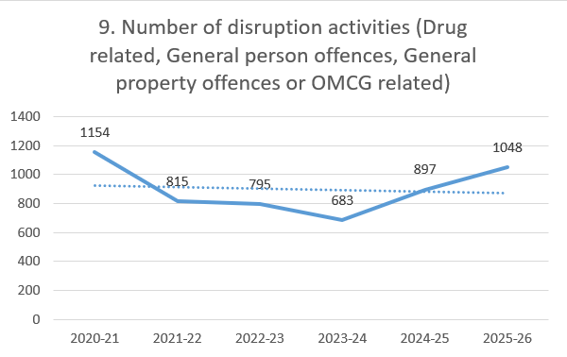
*Figures for the 2025-26 FY have been provided on a pro-rata basis.
The pro-rata number of disruption activities for 2025-26 is 1048. Whilst the overall trend for the 5-year period is slightly downwards, the past two FYs have shown an encouraging increase from the low results of 2023-24.
Performance Measure 10 – Disruption case study (for inclusion in the ACT Policing Annual Report)
A disruption case study will be included in the 2025-26 ACT Policing Annual Report due for release in October 2026.
Performance Measure 11 – Number of targeted traffic operations (In line with the Road Safety Calendar
Date range | Target | Result
1 Jul 2025 – 31 Dec 2025 | Monitor 5-year trend | 16

*Figures for the 2025-26 FY have been provided on a pro-rata basis.

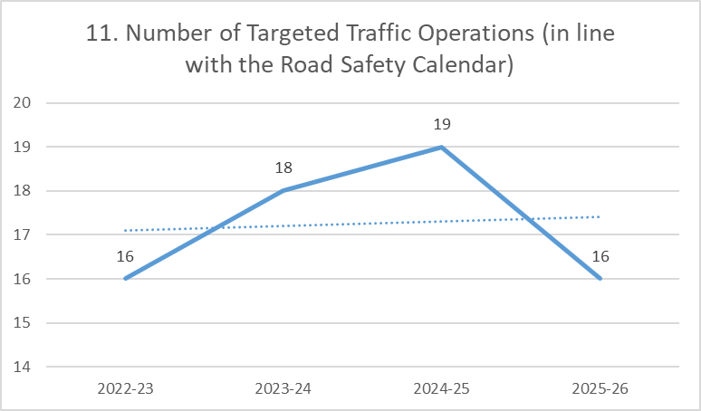
*Figures for the 2025-26 FY have been provided on a pro-rata basis.

For the period 01 July 2025 to 31 December 2025 ACT Road Policing are tracking to complete 16 targeted traffic operations. This figure only takes into account the 8 operations undertaken as part of the 2025-26 Road Safety Calendar.

OUTCOME: Respond
Performance Measure 12 – Average length of time to respond to Priority One incidents
Date range | Target measure | Actual target | Result | % Variation from target | On target
1 Jul 2025 – 31 Dec 2025 | 5 Year average or less | 7.9 minutes or less | 6.5 minutes | -17.4% | Y

As of December 31^{st,} the average length of time to respond to Priority One incidents has been 6.5 minutes. This is 17.4% below the target of 7.9 minutes (the average response time over the past 5 years).
Performance Measure 13 – Average length of time to respond to Priority Two incidents
Date range | Target measure | Actual target | Result | % Variation from target | On target
1 Jul 2025 – 31 Dec 2025 | 5 Year average or less | 17.7 minutes or less | 18.2 minutes | 2.6% | N

As of December 31st, the average length of time to respond to Priority Two incidents was 18.2 minutes. This is 2.6% below the target 17.7 minutes (the average response time over the past 5 years).

Performance Measure 14 – Percentage of Priority Three incidents responded to within 48 hours
Date range | Target | Result
1 Jul 2025 – 31 Dec 2025 | Monitor 5-year trend | 93.6%

Figure 6: Percentage of priority three incidents responded to within 48 hours – 5-year trend
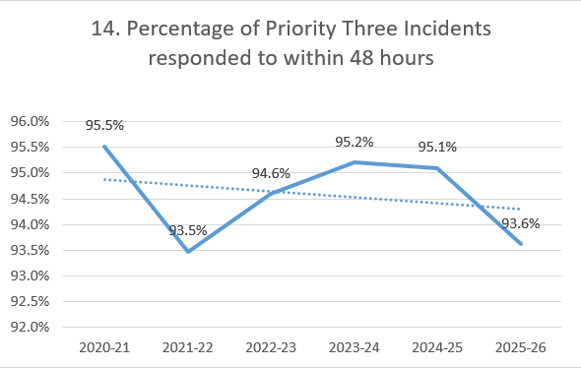
The percentage of priority three incidents responded to within 48 hours is 93.6%. This result is -1.5% below the previous years’ result of 95.1% and is the lowest result since the 2021-22 FY.

Performance Measures 15 a) - Percentage of Triple Zero (000) calls answered on first presentation
Date range | Target measure | Target | Result | % Variation from target | On target
1 Jul 2025 – 31 Dec 2025 | 5 Year average or more | 91.0% or more | 86.6% | 4.4% | N

The percentage of triple zero (000) calls answered on first presentation is 86.6%. This result is 4.4% below the target of 91.0%, which is the average percentage of calls answered on first presentation over the past 5 years.
Performance Measures 15 b) - Percentage of Triple Zero (000) calls answered on second presentation
Date range | Target measure | Target | Result | % Variation from target | On target
1 Jul 2025 – 31 Dec 2025 | 5 Year average or more | 97.3% or more | 94.5% | -2.8% | N

The percentage of triple zero (000) calls answered on second presentation is 94.5%. This result is 2.8% below the target of 97.3%, which is the average percentage of calls answered on second presentation over the past 5 years.
Performance Measure 16 – Percentage of the community satisfied in general with the job police are doing in responding to emergencies and disasters?
Due to a change in collection methodology, an accurate national average is no longer able to be derived from NSCSP data and commentary will not be provided.

OUTCOME: Enforce
Performance Measure 17 – Proportion of offenders proceeded against for person offences
Date range | Target measure | Actual target | Result | % Variation from target | On target
1 Jul 2025 – 31 Dec 2025 | 5-year average or more | 30.1% or more | 36.2% | 6.2% | Y

Performance Measure 18 – Proportion of offenders proceeded against for property offences
Date range | Target measure | Actual target | Result | % Variation from target | On target
1 Jul 2025 – 31 Dec 2025 | 5-year average or more | 7.9% or more | 8.1% | 0.1% | Y

OUTCOME: Community Confidence
Performance Measure 19 - Percentage of the community satisfied in general with services provided by police
Due to a change in collection methodology, an accurate national average is no longer able to be derived from NSCSP data and commentary will not be provided.
Performance Measure 20 - Percentage of the community who have confidence in police
Due to a change in collection methodology, an accurate national average is no longer able to be derived from NSCSP data and commentary will not be provided.
Performance Measure 21 – Number of complaints against police
Date Range | Target | Result
1 Jul 2025 – 31 Dec 2025 | Monitor 5-year trend | 46

Figure 7: Number of complaints against police – 5-year trend

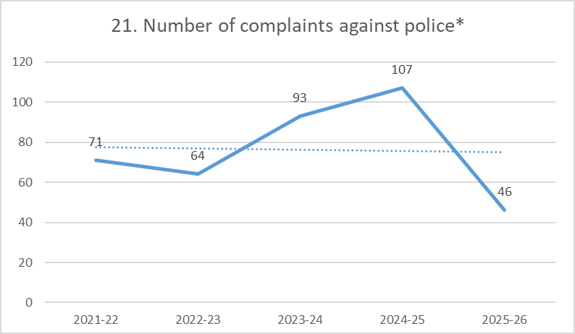
*Figures for the 2025-26 FY have been provided on a pro-rata basis.
The pro-rata number of complaints against police for 2025-26 is 46. Based on this result, ACT Policing is on track to record its lowest number of complaints over the 5-year period.

4. Ministerial Direction and Statement of Intent

Professionalism and practices of positive community engagement
ACT Policing demonstrates a structured and forward-looking commitment to continual improvement through investment in technology, research, workforce development, and enhancing processes.
A dedicated Continuous Improvement capability evaluates and drives reform projects, ensuring they align with organisational and ACT Government priorities.
Technology-enabled solutions, including the expanding Online Reporting Portal, voice-to-text transcription tools, enhanced closed circuit television integration, and digital evidence portals are streamlining frontline work, improving data quality, and enhancing service accessibility for the community.
Evidence-based decision-making is a guiding principle of ACT Policing and is supported through structured research, community engagement, and evaluation initiatives. These include studies informing trauma-informed policing, First Nations engagement frameworks, public safety perception insights, and improvements to domestic and family violence responses.
ACT Policing prioritises workforce capability and wellbeing through targeted training, cultural literacy programs, and wellbeing initiatives to reinforce a healthy, skilled and resilient workforce capable of delivering modern policing services.
These initiatives reflect ACT Policing’s commitment to being a highly visible, responsive and proactive policing service, continually evolving to meet the needs of the ACT community.
ACT Policing continues to enjoy the trust and confidence of the ACT community as reflected in the annual Report on Government Services.
ACT Policing builds trust through consistent, community-focused engagement that prioritises visibility, approachability and cultural awareness.
Dedicated liaison teams work closely with vulnerable groups, while regular face-to-face initiatives—such as Coffee with a Cop, Cop Pop Ups, and attendance at key community events—create relaxed opportunities for conversations and relationship building,
These teams conduct targeted outreach to First Nations, Culturally and Linguistically Diverse (CALD) communities, and groups experiencing safety concerns fostering respectful partnerships grounded in cultural understanding.
ACT Policing’s high-visibility patrols and open communication with residents and businesses further strengthen public confidence, demonstrating ACT Policing’s commitment to listening, responding and working collaboratively with the community.
ACT Policing maintains that the overwhelming majority of interactions officers have with the community are appropriate and are conducted with care, professionalism and to the high standards expected by ACT Policing and the community.
To maintain the trust and confidence of the community that police powers are being exercised appropriately and responsibly, ACT Policing acknowledges and welcomes the need for transparency and accountability.
In 2024 and 2025, ACT Policing transparently and constructively engaged with the ACT Ombudsman in the conduct of the Ombudsman’s Own Motion Investigation (OMI) regarding the Use of Force by ACT Policing.
ACT Policing acknowledge there are elements within each of the eight recommendations in the report that show where police actions or policies can be improved or enhanced and have committed to addressing those specific areas.
ACT Policing has established additional governance to ensure that matters are identified, assessed and appropriate responses are implemented to address issues regarding training, processes, frameworks and, where required, the conduct of ACT Policing members. This includes the Operational Practices Committee which holds responsibility for implementing the outcomes of the OMI.
ACT Policing takes all allegations of member misconduct seriously and is committed to continuous improvement in its complaints management processes.
The AFP has commenced an independent review of the AFP’s complaints management process to ensure the AFP maintains a mature and defensible complaint management system. The AFP has engaged with the Office of the Commonwealth Ombudsman in development of terms of reference for the review and the Office of the Commonwealth Ombudsman will be a key stakeholder consulted during the review. The review has commenced and is expected to be completed before the end of October 2026.

Crime prevention
ACT Policing’s highest priority is ensuring that all members of the ACT community feel safe and supported.
The organisation contributes to whole-of-government crime-reduction efforts by supporting initiatives that minimise opportunities for offending, including, strengthened investigative partnerships, and enhancements to forensic, intelligence and judicial processes.
ACT Policing continues to monitor and respond to emerging crime trends through proactive and targeted capabilities, adapting its methods to remain a flexible and responsive policing organisation.
Through sustained collaboration with stakeholders and the application of intelligence-led strategies, ACT Policing identifies emerging issues early and implements effective solutions that promote a safer environment for the entire community.

Implement effective domestic and family violence prevention and response
Domestic and Family Violence (DFV) remains a high operational priority for ACT Policing – with a pro-arrest, pro-charge and presumption against bail approach to incidents when matters are reported.
ACT Policing recognises the importance of community-led solutions to support and prevent further harm to victim-survivors of DFV.
The majority of responses to and investigation of DFV incidents in the ACT are carried out by frontline uniform patrol officers across the five ACT Policing stations.
The high-risk Domestic and Family Violence Investigation unit (DFVIU) has enabled specialist investigators to focus on the highest risk domestic and family violence matters, as well as providing support and advice to frontline officers who are the first responders to those incidents.
The DFVIU ensures that the most at-risk victim-survivors get the appropriate support and that the offenders are engaged to ensure they are complying with court orders and other sanctions.
The Family Violence Coordination Unit (FVCU), a specialist unit that provides support and education to frontline police, works closely with the Family Violence Safety Action Program to support whole-of-sector approaches to supporting victim-survivor safety, along with partner agencies the Domestic Violence Crisis Service, Children Youth and Families and Canberra Rape Crisis Centre.
ACT Policing equips frontline members with up-to-date knowledge to protect victims and hold offenders accountable.
Work is underway to design and deliver enhanced domestic and family violence training for ACT Policing officers to increase officers’ knowledge and understanding of coercive control and trauma-informed best practice.

Implement effective sexual assault prevention and responses
ACT Policing takes all sexual assault matters seriously and has specialist investigators in the Sexual Offences and Child Abuse (SOCA) teams who investigate matters and guide victim-survivors through each step of the process.
ACT Policing works closely with victim support groups such as the Canberra Rape Crisis Centre, the ACT Intermediary Program within the ACT Human Rights Commission and Victims Support ACT to deliver a high level of support and care to victim-survivors.
Since the release of the Sexual Assault Prevention and Review report in 2024 significant work has been undertaken to strengthen oversight, improve investigative processes, and elevate leadership within SOCA. New training reforms and decision-making structures ensure consistent, accountable and high-quality responses.
The long-term focus for ACT Policing has always been to put decision making into the hands of the victim-survivor at the centre of the process so their voice is heard in relation to how their matter proceeds.
Combat dangerous driving
ACT Policing works in partnership with the ACT Government to develop and implement strategies aimed at improving road safety and reducing anti-social and dangerous driving behaviours. This includes joint education campaigns and focused operational activity aligned with the Road Safety Calendar, which focus on enhancing road culture and driving behaviour.
These efforts address dangerous driving and the ‘fatal five’— impaired driving, speeding, failure to stop, seatbelt non-compliance and distraction.
Enhanced enforcement, legislative reforms on licence suspensions and vehicle seizures, and roadside drug testing expansions have strengthened ACT Policing’s ability to prevent and respond to risky driving.
ACT Policing’s Proactive Policing capability continues to target recidivist offending across Canberra, including but not limited to dangerous driving. Large scale, high-visibility traffic enforcement operations are also conducted periodically to reinforce safe driving practices.
Online reporting for dangerous driving, including dash-cam submissions, has enhanced ACT Policing’s ability to identify and address unsafe driving behaviours.
Between 1 July to 31 December 2025, a total of 1,397 online Dangerous Driving reports were received, and 1,070 Traffic Infringement Notices (TINS), 235 Cautions and 158 warning letters were issued. (Note – some reports contain evidence of more than one offence and so the number of TINs and cautions may be greater than the number of reports received.)
Reducing the over-representation of Aboriginal and Torres Strait Islander people in the criminal justice system
The over-representation of First Nations people in the criminal justice system remains a deeply concerning issue. ACT Policing continues to work with First Nations communities, non-government organisations and partner agencies to design programs and initiatives that better support those who come into contact with police.
Senior leadership engagement, including community events, forums, liaison partnerships and yarning circles, remains vital to sustaining meaningful progress.
ACT Policing First Nations Liaison Officers have continued to support areas within ACT Policing to build and maintain relationships with victims, witnesses and suspects for matters including working with General Duties and Criminal Investigations officers.
ACT Policing is committed to fair and equitable policing practices and regularly reviews policies, procedures and training to ensure members uphold the principles of impartiality and respect for all communities in Canberra.
ACT Policing continues its implementation of recommendations made through the Ombudsman’s Own Motion Investigation (OMI) into ACT Policing’s administrative framework for engagement with the ACT’s Aboriginal and Torres Strait Islander community and maintains an active commitment to reconciliation and improving outcomes for First Nations people. ACT Policing have advanced implementation of all nine recommendations with the final recommendation expected to be launched in the first quarter of 2026.

Raising the Minimum age of Criminal Responsibility (MACR)
ACT Policing continues to support measures to divert young people from the criminal justice system and, where appropriate, to provide young people with support options rather than the laying of charges.
Through a coordinated, multiagency approach, ACT Policing and partner organisations are working to identify at-risk young people early and ensure they receive the support they need.
Officers continue to respond to all incidents involving young people, ensuring safety and applying the principles of the Minimum Age of Criminal Responsibility reforms when determining the most appropriate pathway forward.
ACT Policing continues to work with the ACT Government and stakeholders to support and monitor the implementation of the MACR reforms, including advocating for appropriate resourcing, capability and capacity of support services to provide timely response and support to police.

Drug decriminalisation and harm minimisation
ACT Policing places the safety and wellbeing of the community first and foremost and supports a whole-of-government response to reduce the social harm caused by drugs.
ACT Policing continues to work with ACT Health partners to support harm minimisation and health protection initiatives for the safety and wellbeing of all ACT residents.
ACT Policing’s focus remains on those who bring drugs into the Territory and profit from their distribution among the community. We will continue to target drug trafficking and criminality driven by drug use, not drug possession offences.
Community safety focussed firearms approach
ACT Policing supports a community-focused approach to firearms by working closely with the ACT Government to progress reforms that strengthen public safety and ensure firearms are appropriately regulated.
This includes actively contributing to firearms law and policy reform, particularly in response to national security incidents, and supporting efforts toward nationally consistent firearms regulation that reflects local community needs.

Countering terrorism and violent extremism
ACT Policing remains ready to respond to threats of radicalisation and extremism among people in the community, and supportive of furthering initiatives to counter extremism.
ACT Policing continually assesses security risks across the Territory and remains adaptive to the environment, continually evolving our approach and measures taken including active engagement with key community groups to ensure community cohesion and safety.
                - ACT Policing has a dedicated Countering Violent Extremism Case Manager role within the Education and Diversion Team of the Vulnerable Persons portfolio.
                - The ACT Fixated Threat Assessment Centre (FTAC) continues to assess and mitigate the threat of harm posed by persons with demonstrated fixated behaviours and persons vulnerable to engaging in lone-actor, grievance-fuelled violence, where there is suspected or known mental illness or mental disorder influencing behaviours and a pathological grievance, evidence of radicalisation or interest in extremism.
                - FTAC plays a vital role in assessing and providing early intervention to members of the community at risk of fixated behaviour towards Members of the Legislative Assembly and ACT Government officials, or lone-actor, grievance-fuelled violence towards the broader ACT community.

